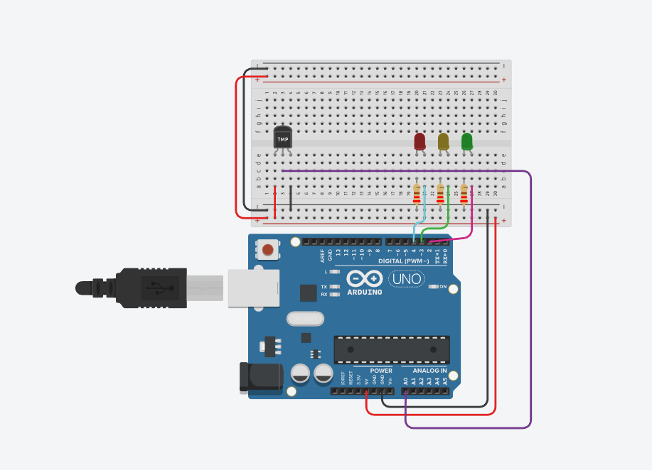

// C++ code
//
int thresholdTemp = 0;
int celsius = 0;
int fahrenheit = 0
void setup()
{
pinMode(A0, INPUT);
Serial.begin(9600);
pinMode(2, OUTPUT);
pinMode(3, OUTPUT);
pinMode(4, OUTPUT);
}
void loop()
{
// set threshold temperature to activate LEDs
thresholdTemp = 40;
// measure temperature in celsius
celsius = map(((analogRead(A0) - 20) * 3.04), 0, 1023, -40, 125);
// converting to Fahrenheit
fahrenheit = ((celsius * 9) / 5 + 32);
Serial.print(celsius);
Serial.print("C");
Serial.print(fahrenheit);
Serial.println("F");
if (celsius < thresholdTemp) {
digitalWrite(2, LOW);
digitalWrite(3, LOW);
digitalWrite(4, LOW);
}
if (celsius >= thresholdTemp && celsius < thresholdTemp + 10 ) {
digitalWrite(2, HIGH);
digitalWrite(3, LOW);
digitalWrite(4, LOW);
}
if (celsius >= thresholdTemp + 10 && celsius < thresholdTemp + 20) {
digitalWrite(2, HIGH);
digitalWrite(3, HIGH);
digitalWrite(4, LOW);
}
if (celsius >= thresholdTemp + 20) {
digitalWrite(2, HIGH);
digitalWrite(3, HIGH);
digitalWrite(4, HIGH);
}
delay(1000); // Wait for 1000 millisecond(s)
}
CONCLUSION - it measures temperature from a sensor and lights up LEDs based on specific temperature thresholds. When the temperature is below 40°C, all LEDs are off; as the temperature increases past 40°C, one to three LEDs light up incrementally for 10°C intervals, indicating rising temperature levels. The current temperature (in both Celsius and Fahrenheit) is also displayed over serial output every second.

